Hello,

An example Flutter weather app using the [OpenWeatherMap API](https://openweathermap.org/api).

## **Features**

* Current weather (base on current location of device, if location permission denied then getting current location from ip location)
* 5-day weather forecast
* Historical Data
* Nearby City Weather on Google Map

## **Architecture**

The app is composed of two main layers.

### **Data Layer**

The data layer contains a single weather repository that is used to fetch weather data from the [OpenWeatherMap API](https://openweathermap.org/api).

The data is then parsed (using [Freezed](https://pub.dev/packages/freezed)) and returned using type-safe entity classes (Weather,Forecast,History and iPLocation).

### **Presentation Layer**

This layer holds all the widgets, along with their controllers.

Widgets do not communicate directly with the repository.

Instead, they watch some controllers that extend the StateNotifier class (using [Riverpod](https://pub.dev/packages/riverpod)).

This allows to map the data from the layer above to AsyncValue objects that can be mapped to the appropriate UI states (data, loading, error).

## 

## **Packages in use**

* [riverpod](https://pub.dev/packages/riverpod) for state management
* [freezed](https://pub.dev/packages/freezed) for code generation
* [http](https://pub.dev/packages/http) for talking to the REST API
* [cached_network_image](https://pub.dev/packages/cached_network_image) for caching images
* [mocktail](https://pub.dev/packages/mocktail) for testing
* [permission_handler](https://pub.dev/packages/permission_handler) for location permission
* [geolocator](https://pub.dev/packages/geolocator) for user current location
* [google_map_flutter](https://pub.dev/packages/google_maps_flutter) for showing google map

## **Screenshots**

1. **Current weather**

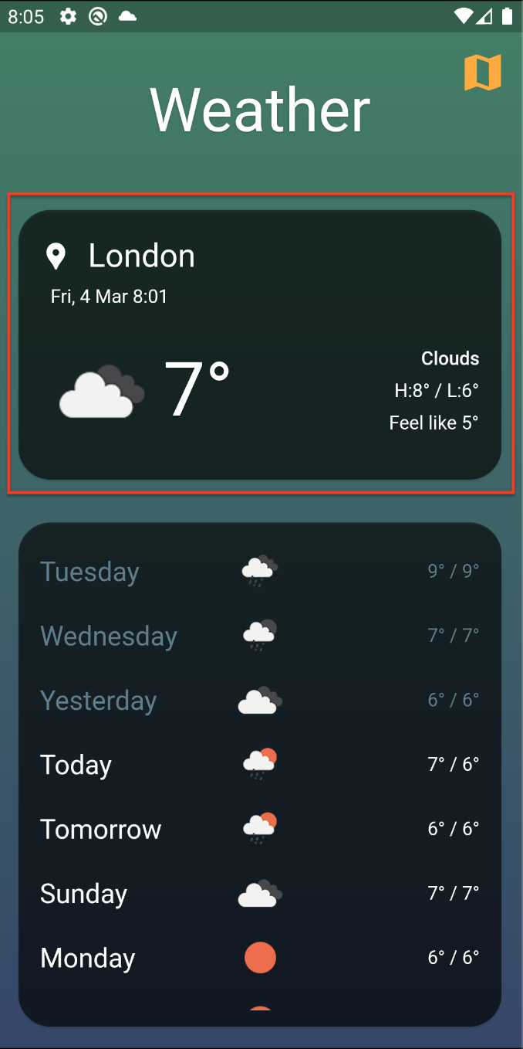

1. **5-Day Daily forecast**

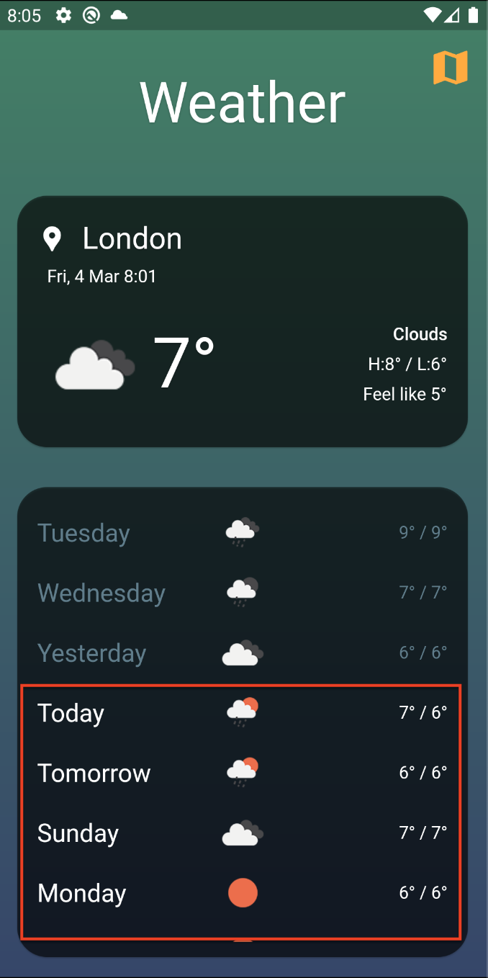

1. **Historical forecast for last 4 days**

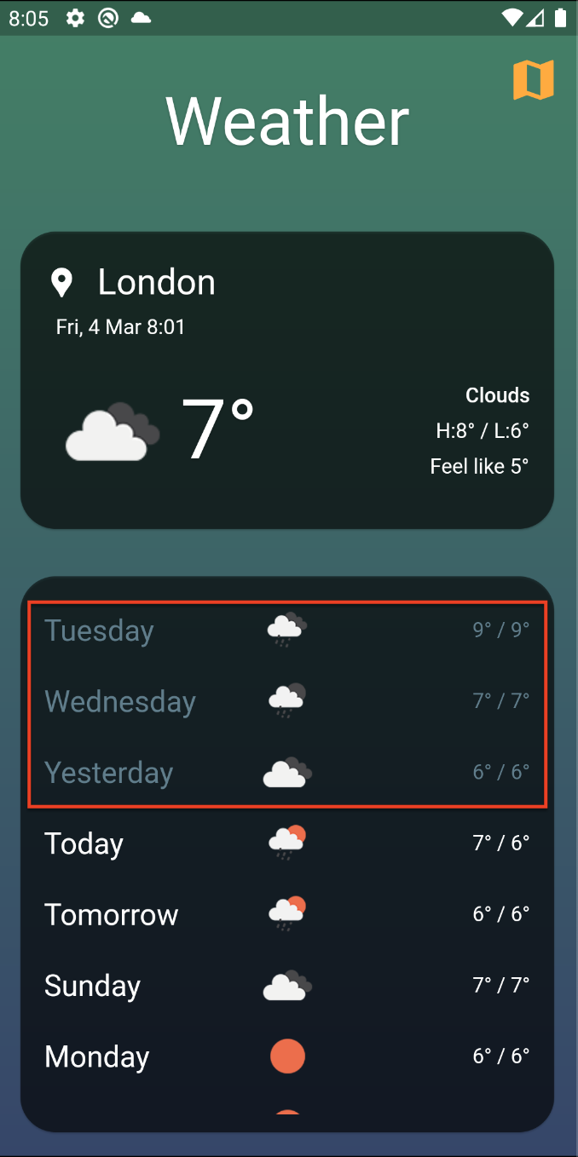

1. **Nearby 10 city weather data on Map**

